**Phase 4: UI / Lightning App & Page Customization**

**1. Objective of this Phase**

The goal of Phase 4 was to create a **Support Agent Console** and a **Customer Portal Experience** that allows both internal users (agents/managers) and external customers to easily:

* View & manage loyalty program data.
* Access related Orders, Cases, and Loyalty Members from a single view.
* Submit Reward Redemption requests via a portal.
* Use dashboards and reports to track progress.

**2. Support Agent Console App**

We designed a **Lightning App (Support Agent Console)** tailored for agents.

**2.1 Setup**

* Created a new Lightning App → **Support Agent Console**.
* Enabled **Navigation Style: Console Navigation** for multi-tab use.
* Added navigation items:
  + Cases
  + Orders
  + Contacts
  + Loyalty Members
  + Reward Redemptions
  + Reports & Dashboards

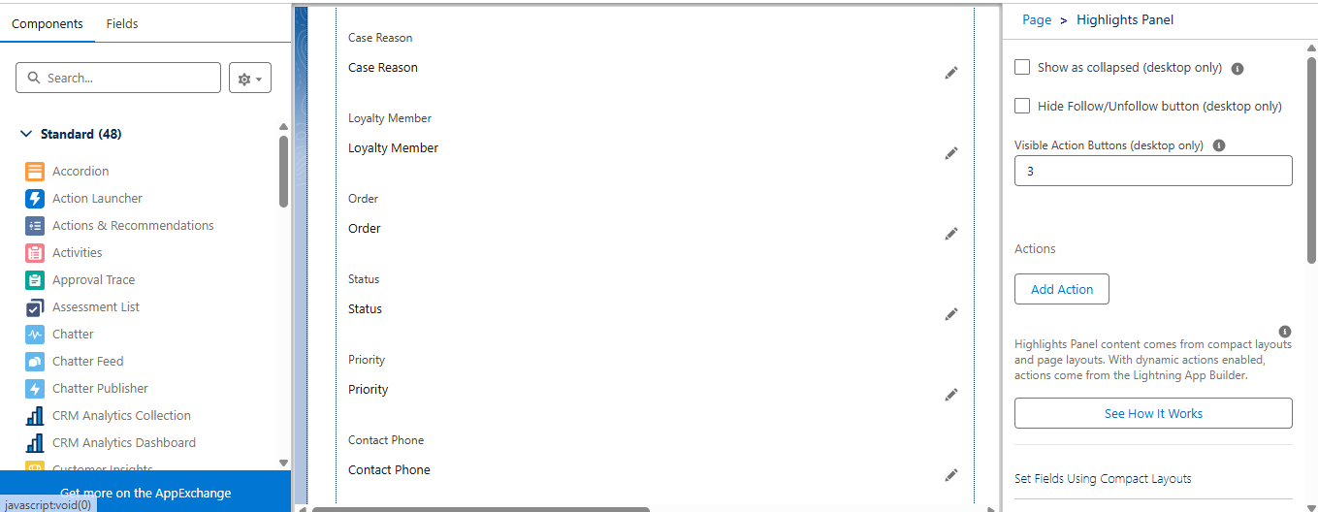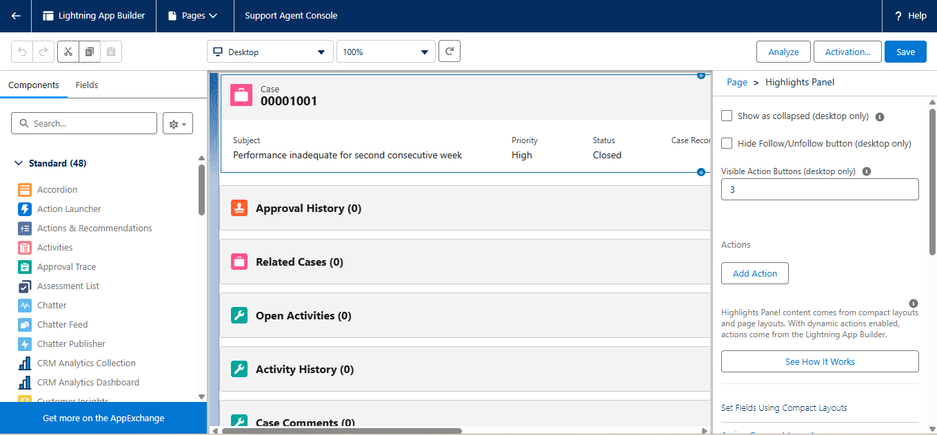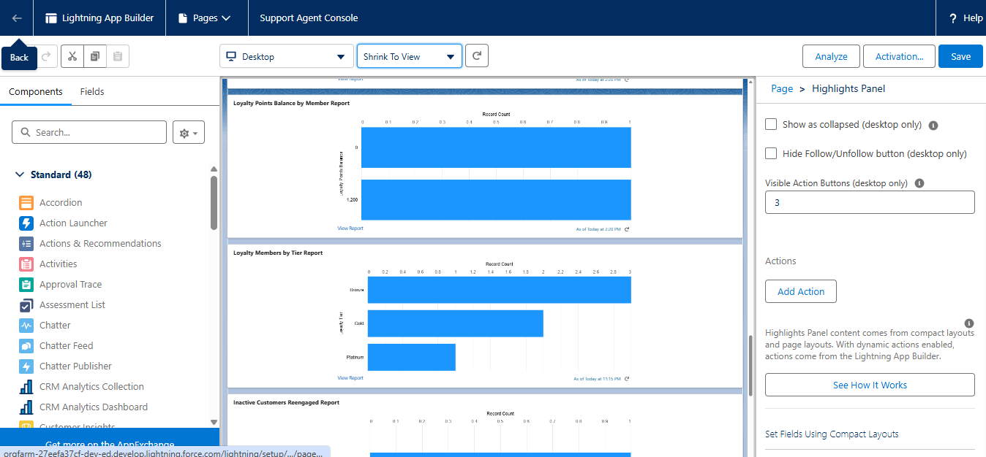

**3. Record Page Customization**

We customized **Lightning Record Pages** for key objects.

**3.1 Contact Record Page**

* Regions used: **Header and Three Regions** layout.
* Components added:
  + **Highlights Panel** → Quick info (Name, Email, Loyalty Tier).
  + **Related Lists** → Orders, Loyalty Members, Cases.
  + **Record Detail** → All standard + custom fields.
  + **Report Chart** (optional) → Loyalty Points Balance summary.

**3.2 Order Record Page**

* Added:
  + **Record Detail** → Order info.
  + **Related List** → Order Products (Items).
  + **Related List** → Loyalty Transactions.
  + **Tabs** → Details | Related | Loyalty History.

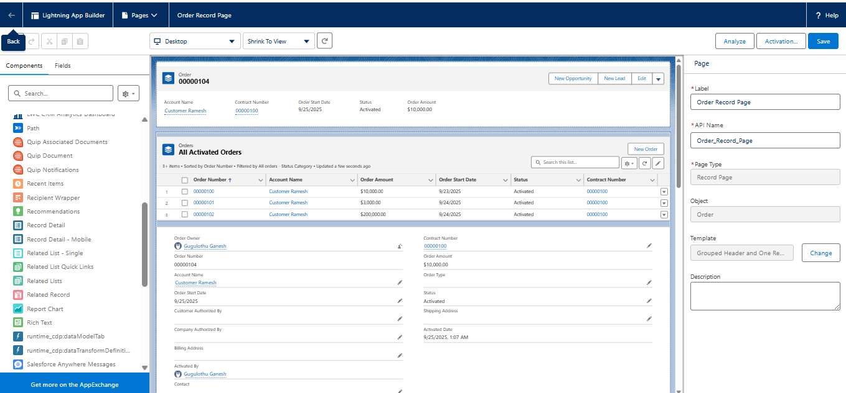

**3.3 Loyalty Member Record Page**

* Added:
  + **Record Detail** → Tier, Balance, Contact.
  + **Related List** → Loyalty Points History.
  + **Related List** → Reward Redemptions.

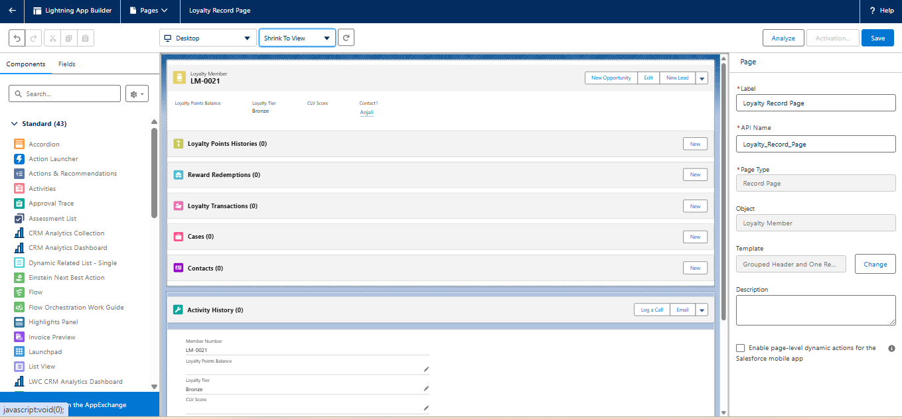

**4. Customer Portal (Experience Cloud)**

We built a **Customer Self-Service Portal** for loyalty program interaction.

**4.1 Portal Setup**

* Enabled **Experience Cloud Sites**.
* Created a new **Customer Portal** site.
* Branded with project theme (logo, colors).

**4.2 Portal Features**

* **Reward Redemption Flow** embedded in portal.
* **Contact Record Access** → Customer sees their loyalty profile.
* **Knowledge Articles** → FAQs on earning/redeeming points.
* **Cases** → Customers can raise service requests.

**5. Reports & Dashboards Integration**

We made dashboards visible inside the **Support Agent Console** app.

* Added **Dashboards component** to the Console Home Page.
* Reports created (Phase 8) were embedded in dashboards.
* Example: "Loyalty Program Dashboard" → shows:
  + Total Active Members
  + Loyalty Points Distribution
  + Orders Driving Points
  + Reward Redemption Status

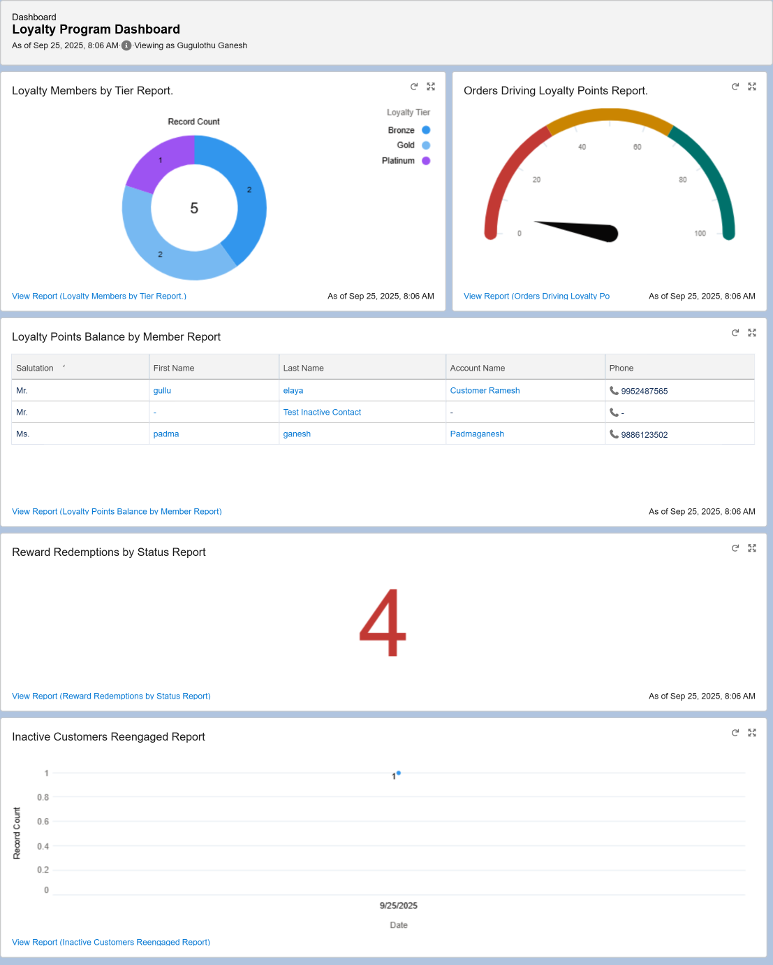

**6. Summary of Phase 4**

At the end of Phase 4, we had:  
✔ A **Support Agent Console App** with Cases, Orders, Loyalty data, and Dashboards.  
✔ Customized **Lightning Record Pages** for Contact, Order, and Loyalty Member.  
✔ A **Customer Portal** where customers can redeem rewards and see their details.  
✔ Dashboards integrated into console for quick insights.